**Assignment -3**

Python Programming

|  |  |
| --- | --- |
| Assignment Date | 19 September 2022 |
| Student Name | Assifa.A |
| Student Roll Number | 311819106004 |
| Maximum Marks | 2 Marks |

**Question-1:**

Consider a list (list = []). You can perform the following commands: insert i e: Insert integer at position . print: Print the list. remove e: Delete the first occurrence of integer . append e: Insert integer at the end of the list. sort: Sort the list. pop: Pop the last element from the list.

reverse: Reverse the list.

Initialize your list and read in the value of followed by lines of commands where each command will be of the types listed above. Iterate through each command in order and perform the corresponding operation on your list.

**Solution:**

if __name__ == '__main__':

N = int (input ())

L= [];

For i in range (0, N):

Cmd= input (). Split ();

if cmd[0] == "insert":

L.insert(int(cmd[1]), int(cmd[2]))

elif cmd[0] == "append":

L.append(int(cmd[1]))

elif cmd[0] == "pop":

L.pop();

elif cmd[0] == "print":

print(L)

elif cmd[0] == "remove":

L.remove(int(cmd[1]))

elif cmd[0] == "sort":

L.sort();

else:

L.reverse();

**OUTPUT:**

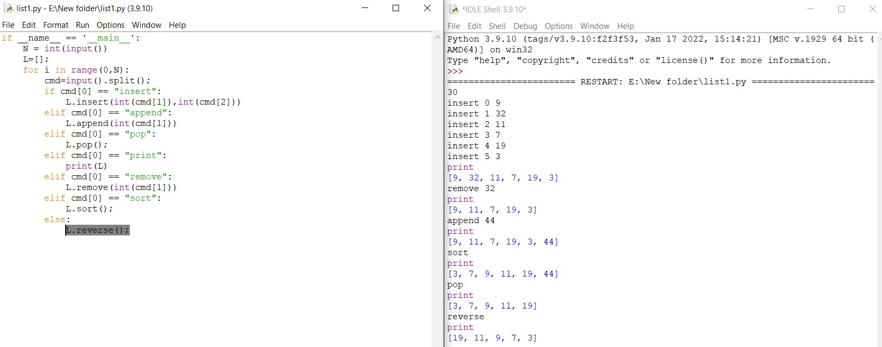

Hence the output forConsider a list (list = []). You can perform the following commands: insert i e: Insert integer at position . print: Print the list. remove e: Delete the first occurrence of integer . append e: Insert integer at the end of the list. sort: Sort the list. pop: Pop the last element from the list.

reverse: Reverse the list.

Initialize your list and read in the value of followed by lines of commands where each command will be of the types listed above. Iterate through each command in order and perform the corresponding operation on your list is shown.

**Question-2:**

Write a Calculator program in Python?

**Solution:**

def add(x, y):

return x + y

def subtract t(x, y):

return x - y

def multiply(x, y):

return x * y

def divide(x, y):

return x / y

print("Select operation.

print("1.Add")

print("2.Subtract")

print("3.Multiply")

print("4.Divide")

while True:

choice = input("Enter choice(1/2/3/4): ")

if choice in ('1', '2', '3', '4'):

num1 = float(input("Enter first number: "))

num2 = float(input("Enter second number: "))

if choice == '1':

print(num1, "+", num2, "=", add(num1, num2))

elif choice == '2':

print(num1, "-", num2, "=", subtract(num1, num2))

elif choice == '3':

print(num1, "*", num2, "=", multiply(num1, num2))

elif choice == '4':

print (num1, "/", num2, "=", divide (num1, num2))

next_calculation = input("Let's do next calculation? (yes/no): ")

if next_calculation == "no":

break else:

print("Invalid Input")

**OUTPUT:**

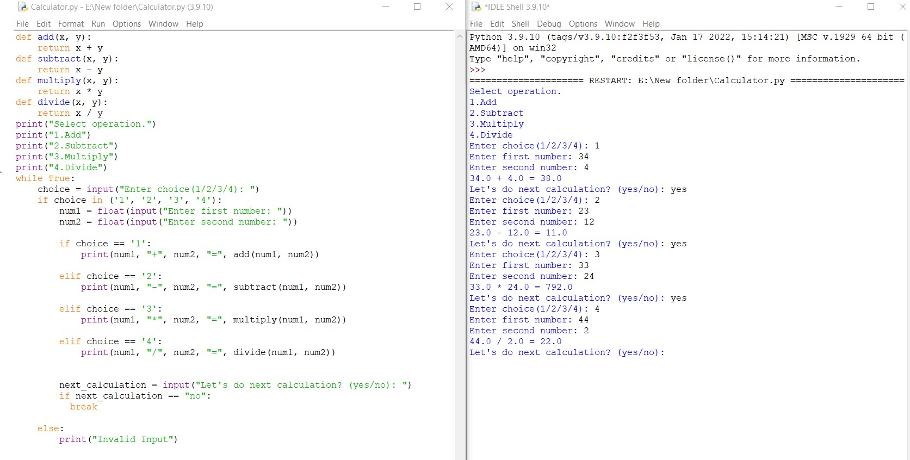

Hence the output for a Calculator program in Python is shown.

**Question-3:**

Write a program to concatenate, reverse and slice a string?

**Solution:**

var1 = "Hello " var2 = "World" var3 = var1 + var2 print("The concatenated string:")

print(var3)

txt = "Hello World"[::-1] print("The reversed string:")

print(txt)

txt1 = "Hello, World!"

print("The sliced string:") print(txt1[6:11])

**OUTPUT:**

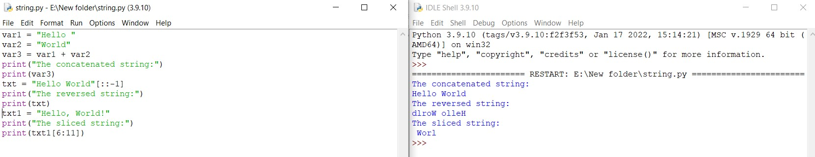

Hence the output for program to concatenate, reverse and slice a string is shown.

**Question-4:**

Why is Python a popular programming language?

One of the main reasons it is popular as a programming language is that it's a great way to learn how to code. It reads almost like plain English and has many features that allow you to write complex tasks very simply.Python is a high-level programming language. Python is very easy to learn the language as compared to other languages like C, C#, Javascript, Java, etc. It is very easy to code in python language.

**Question-5:**

What are the other Frameworks that can be used with python?

Django

Pyramid

Circuits

Flask

Cherrypy

TurboGears

Web2py

**Question-6:**

Full form of WSGI?

WSGI refers to Web Server Gateway Interface. WSGI plays a vital role at the time when deploy Django or Flask application.